**MAHENDRA ENGINEERING COLLEGE FOR WOMEN**

**ASSIGNMENT II SOLUTION**

**NAME OF THE STUDENT : N.RAAMI**

**REGISTER NUMBER : 611419205023**

**YEAR/DEPARTMENT : IV-IT**

*#libraries*

import pandas as pd import numpy as np

import matplotlib.pyplot as plt

%matplotlib inline

*#load dataset*

df = pd.read_csv(r"/content/Churn_Modelling.csv") df.head(10)

|  |  |  |  |  |  |  |  |  |  |  |
| --- | --- | --- | --- | --- | --- | --- | --- | --- | --- | --- |
| \ | RowNumber | | CustomerId | | Surname | CreditScore | Geography | Gender | | Age |
| 0 | 1 | | 15634602 | | Hargrave | 619 | France | Female | | 42 |
| 1 | 2 | | 15647311 | | Hill | 608 | Spain | Female | | 41 |
| 2 | 3 | | 15619304 | | Onio | 502 | France | Female | | 42 |
| 3 | 4 | | 15701354 | | Boni | 699 | France | Female | | 39 |
| 4 | 5 | | 15737888 | | Mitchell | 850 | Spain | Female | | 43 |
| 5 | 6 | | 15574012 | | Chu | 645 | Spain | Male | | 44 |
| 6 | 7 | | 15592531 | | Bartlett | 822 | France | Male | | 50 |
| 7 | 8 | | 15656148 | | Obinna | 376 | Germany | Female | | 29 |
| 8 | 9 | | 15792365 | | He | 501 | France | Male | | 44 |
| 9 | 10 | | 15592389 | | H? | 684 | France | Male | | 27 |
|  | Tenure | Balance | | NumOfProducts | | HasCrCard | IsActiveMember | | \ | |
| 0 | 2 | 0.00 | | 1 | | 1 | 1 | |  | |
| 1 | 1 | 83807.86 | | 1 | | 0 | 1 | |  | |
| 2 | 8 | 159660.80 | | 3 | | 1 | 0 | |  | |
| 3 | 1 | 0.00 | | 2 | | 0 | 0 | |  | |
| 4 | 2 | 125510.82 | | 1 | | 1 | 1 | |  | |
| 5 | 8 | 113755.78 | | 2 | | 1 | 0 | |  | |
| 6 | 7 | 0.00 | | 2 | | 1 | 1 | |  | |
| 7 | 4 | 115046.74 | | 4 | | 1 | 0 | |  | |
| 8 | 4 | 142051.07 | | 2 | | 0 | 1 | |  | |
| 9 | 2 | 134603.88 | | 1 | | 1 | 1 | |  | |
|  | EstimatedSalary | | | Exited | | | | | | |
| 0 | 101348.88 | | | 1 | | | | | | |
| 1 | 112542.58 | | | 0 | | | | | | |
| 2 | 113931.57 | | | 1 | | | | | | |

|  |  |  |
| --- | --- | --- |
| 3 | 93826.63 | 0 |
| 4 | 79084.10 | 0 |
| 5 | 149756.71 | 1 |
| 6 | 10062.80 | 0 |
| 7 | 119346.88 | 1 |
| 8 | 74940.50 | 0 |
| 9  df.info() | 71725.73 | 0 |

<class 'pandas.core.frame.DataFrame'> RangeIndex: 10000 entries, 0 to 9999 Data columns (total 14 columns):

# Column Non-Null Count Dtype

1. RowNumber 10000 non-null int64
2. CustomerId 10000 non-null int64
3. Surname 10000 non-null object
4. CreditScore 10000 non-null int64
5. Geography 10000 non-null object
6. Gender 10000 non-null object
7. Age 10000 non-null int64
8. Tenure 10000 non-null int64
9. Balance 10000 non-null float64
10. NumOfProducts 10000 non-null int64
11. HasCrCard 10000 non-null int64
12. IsActiveMember 10000 non-null int64
13. EstimatedSalary 10000 non-null float64
14. Exited 10000 non-null int64 dtypes: float64(2), int64(9), object(3) memory usage: 1.1+ MB

*#Visualizations #Univariate Analysis* import seaborn as sns

sns.kdeplot(df['CreditScore'])

<matplotlib.axes._subplots.AxesSubplot at 0x7fc4a0cd2790>

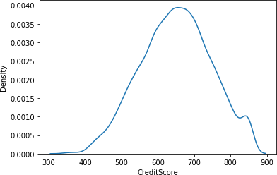

*#Bi - Variate Analysis*

plt.bar(df.CustomerId, df.CreditScore) plt.title('CreditScore') plt.xlabel('CustomerId') plt.ylabel('CreditScore')

Text(0, 0.5, 'CreditScore')

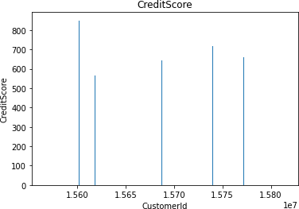

sns.lmplot(x='Tenure', y='Balance', data=df ,hue='Exited',size=8)

/usr/local/lib/python3.7/dist-packages/seaborn/regression.py:581: UserWarning: The `size` parameter has been renamed to `height`; please update your code.

warnings.warn(msg, UserWarning)

<seaborn.axisgrid.FacetGrid at 0x7fc4a149e2d0>

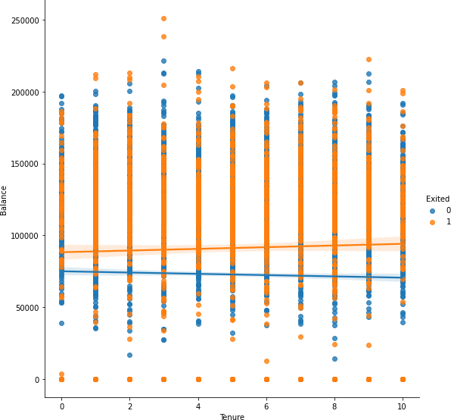

*#Multi - Variate Analysis*

ax = df[["CreditScore","Age","Tenure","Balance"]].plot(figsize=(80,40)) ax.legend(loc='center left', bbox_to_anchor=(1, 0.5));

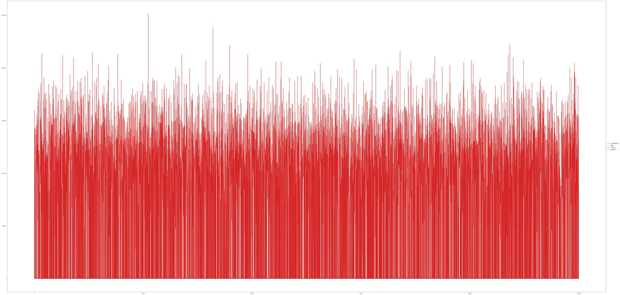

df.isnull().sum()

RowNumber 0

CustomerId 0

Surname 0

CreditScore 0

Geography 0

Gender 0

Age 0

Tenure 0

Balance 0

NumOfProducts 0

HasCrCard 0

IsActiveMember 0

EstimatedSalary 0

Exited 0

dtype: int64

plt.figure(figsize=(15,13)) sns.heatmap(df.corr(),annot=True,cmap='BuPu') plt.show()

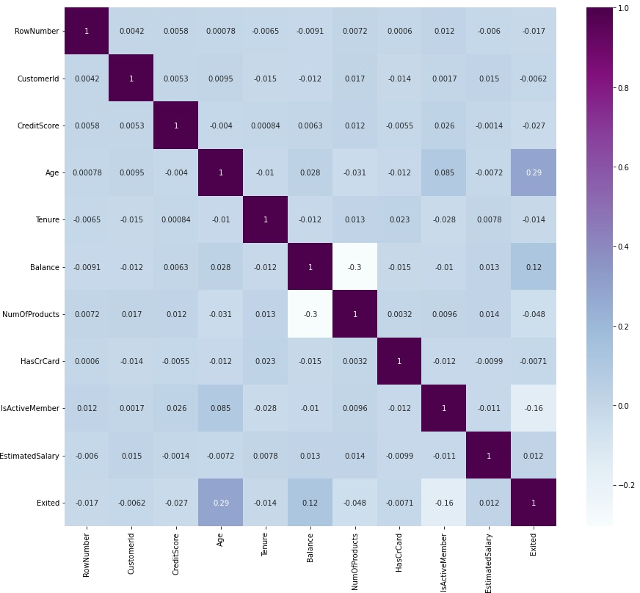

df.drop(['RowNumber', 'CustomerId','Surname'],axis=1,inplace=True) df.head()

|  |  |  |  |  |  |  |
| --- | --- | --- | --- | --- | --- | --- |
| CreditScore  NumOfProducts | | Geography  \ | Gender | Age | Tenure | Balance |
| 0 | 619 | France | Female | 42 | 2 | 0.00 |
| 1 |  |  |  |  |  |  |
| 1 | 608 | Spain | Female | 41 | 1 | 83807.86 |
| 1 |  |  |  |  |  |  |
| 2 | 502 | France | Female | 42 | 8 | 159660.80 |
| 3 |  |  |  |  |  |  |
| 3 | 699 | France | Female | 39 | 1 | 0.00 |
| 2 |  |  |  |  |  |  |
| 4 | 850 | Spain | Female | 43 | 2 | 125510.82 |
| 1 |  |  |  |  |  |  |

HasCrCard IsActiveMember EstimatedSalary Exited 0 1 1 101348.88 1

|  |  |  |  |  |
| --- | --- | --- | --- | --- |
| 1 | 0 | 1 | 112542.58 | 0 |
| 2 | 1 | 0 | 113931.57 | 1 |
| 3 | 0 | 0 | 93826.63 | 0 |
| 4  df.info() | 1 | 1 | 79084.10 | 0 |

<class 'pandas.core.frame.DataFrame'> RangeIndex: 10000 entries, 0 to 9999 Data columns (total 11 columns):

# Column Non-Null Count Dtype

1. CreditScore 10000 non-null int64
2. Geography 10000 non-null object
3. Gender 10000 non-null object
4. Age 10000 non-null int64
5. Tenure 10000 non-null int64
6. Balance 10000 non-null float64
7. NumOfProducts 10000 non-null int64
8. HasCrCard 10000 non-null int64
9. IsActiveMember 10000 non-null int64
10. EstimatedSalary 10000 non-null float64
11. Exited 10000 non-null int64 dtypes: float64(2), int64(7), object(2) memory usage: 859.5+ KB

df["Geography"].unique()

array(['France', 'Spain', 'Germany'], dtype=object) df["Gender"].unique()

array(['Female', 'Male'], dtype=object) geo=pd.get_dummies(df["Geography"],drop_first=False) geo.head()

France Germany Spain 0 1 0 0

1 0 0 1

2 1 0 0

3 1 0 0

4 0 0 1

gen=pd.get_dummies(df["Gender"],drop_first=False) df=pd.concat([df, geo,gen], axis=1)

df

CreditScore Geography Gender Age Tenure Balance NumOfProducts \

|  |  |  |  |  |  |  |
| --- | --- | --- | --- | --- | --- | --- |
| 0 | 619 | France | Female | 42 | 2 | 0.00 |
| 1 |  |  |  |  |  |  |
| 1 | 608 | Spain | Female | 41 | 1 | 83807.86 |
| 1 |  |  |  |  |  |  |
| 2 | 502 | France | Female | 42 | 8 | 159660.80 |
| 3 |  |  |  |  |  |  |
| 3 | 699 | France | Female | 39 | 1 | 0.00 |
| 2 |  |  |  |  |  |  |
| 4 | 850 | Spain | Female | 43 | 2 | 125510.82 |
| 1 |  |  |  |  |  |  |
| ... | ... | ... | ... | ... | ... | ... |
| ... |  |  |  |  |  |  |
| 9995 | 771 | France | Male | 39 | 5 | 0.00 |
| 2 |  |  |  |  |  |  |
| 9996 | 516 | France | Male | 35 | 10 | 57369.61 |
| 1 |  |  |  |  |  |  |
| 9997 | 709 | France | Female | 36 | 7 | 0.00 |
| 1 |  |  |  |  |  |  |
| 9998 | 772 | Germany | Male | 42 | 3 | 75075.31 |
| 2 |  |  |  |  |  |  |
| 9999 | 792 | France | Female | 28 | 4 | 130142.79 |
| 1 |  |  |  |  |  |  |

HasCrCard IsActiveMember EstimatedSalary Exited France Germany \

|  |  |  |  |  |  |  |
| --- | --- | --- | --- | --- | --- | --- |
| 0 | 1 | | 1 | 101348.88 | 1 | 1 |
| 0 |  | |  |  |  |  |
| 1 | 0 | | 1 | 112542.58 | 0 | 0 |
| 0 |  | |  |  |  |  |
| 2 | 1 | | 0 | 113931.57 | 1 | 1 |
| 0 |  | |  |  |  |  |
| 3 | 0 | | 0 | 93826.63 | 0 | 1 |
| 0 |  | |  |  |  |  |
| 4 | 1 | | 1 | 79084.10 | 0 | 0 |
| 0  ...  ... 9995 | ...  1 | | ...  0 | ... 96270.64 | ...  0 | ...  1 |
| 0 |  | |  |  |  |  |
| 9996 | 1 | | 1 | 101699.77 | 0 | 1 |
| 0 |  | |  |  |  |  |
| 9997 | 0 | | 1 | 42085.58 | 1 | 1 |
| 0 |  | |  |  |  |  |
| 9998 | 1 | | 0 | 92888.52 | 1 | 0 |
| 1 |  | |  |  |  |  |
| 9999 | 1 | | 0 | 38190.78 | 0 | 1 |
| 0 |  | |  |  |  |  |
| 0 | Spain  0 | Female  1 | Male  0 | | | |

|  |  |  |  |
| --- | --- | --- | --- |
| 1 | 1 | 1 | 0 |
| 2 | 0 | 1 | 0 |
| 3 | 0 | 1 | 0 |
| 4 | 1 | 1 | 0 |
| ... | ... | ... | ... |
| 9995 | 0 | 0 | 1 |
| 9996 | 0 | 0 | 1 |
| 9997 | 0 | 1 | 0 |
| 9998 | 0 | 0 | 1 |
| 9999 | 0 | 1 | 0 |

[10000 rows x 16 columns] df.drop(["Geography","Gender"], axis=1, inplace=True) df.head()

CreditScore Age Tenure Balance NumOfProducts HasCrCard \ 0 619 42 2 0.00 1 1

1 608 41 1 83807.86 1 0

2 502 42 8 159660.80 3 1

3 699 39 1 0.00 2 0

4 850 43 2 125510.82 1 1

IsActiveMember EstimatedSalary Exited France Germany Spain Female \

|  |  |  |  |  |  |  |  |
| --- | --- | --- | --- | --- | --- | --- | --- |
| 0 |  | 1 | 101348.88 | 1 | 1 | 0 | 0 |
| 1 |  |  |  |  |  |  |  |
| 1 |  | 1 | 112542.58 | 0 | 0 | 0 | 1 |
| 1 |  |  |  |  |  |  |  |
| 2 |  | 0 | 113931.57 | 1 | 1 | 0 | 0 |
| 1 |  |  |  |  |  |  |  |
| 3 |  | 0 | 93826.63 | 0 | 1 | 0 | 0 |
| 1 |  |  |  |  |  |  |  |
| 4 |  | 1 | 79084.10 | 0 | 0 | 0 | 1 |
| 1 |  |  | | | | | |
| 0 | Male  0 |
| 1 | 0 |
| 2 | 0 |
| 3 | 0 |
| 4 | 0 |

x=df.drop('Exited',axis=1) x

|  |  |  |  |  |  |  |  |
| --- | --- | --- | --- | --- | --- | --- | --- |
|  | CreditScore | Age | Tenure | Balance | NumOfProducts | HasCrCard | \ |
| 0 | 619 | 42 | 2 | 0.00 | 1 | 1 |  |
| 1 | 608 | 41 | 1 | 83807.86 | 1 | 0 |  |

|  |  |  |  |  |  |  |  |  |
| --- | --- | --- | --- | --- | --- | --- | --- | --- |
| 2 | 502 | 42 | 8 | 159660.80 | | 3 | 1 | |
| 3 | 699 | 39 | 1 | 0.00 | | 2 | 0 | |
| 4 | 850 | 43 | 2 | 125510.82 | | 1 | 1 | |
| ... | ... | ... | ... | ... | | ... | ... | |
| 9995 | 771 | 39 | 5 | 0.00 | | 2 | 1 | |
| 9996 | 516 | 35 | 10 | 57369.61 | | 1 | 1 | |
| 9997 | 709 | 36 | 7 | 0.00 | | 1 | 0 | |
| 9998 | 772 | 42 | 3 | 75075.31 | | 2 | 1 | |
| 9999 | 792 | 28 | 4 | 130142.79 | | 1 | 1 | |
| Male | IsActiveMember | | EstimatedSalary | | France | Germany | Spain | Female |
| 0 | 1 | | 101348.88 | | 1 | 0 | 0 | 1 |
| 0 |  | |  | |  |  |  |  |
| 1 | 1 | | 112542.58 | | 0 | 0 | 1 | 1 |
| 0 |  | |  | |  |  |  |  |
| 2 | 0 | | 113931.57 | | 1 | 0 | 0 | 1 |
| 0 |  | |  | |  |  |  |  |
| 3 | 0 | | 93826.63 | | 1 | 0 | 0 | 1 |
| 0 |  | |  | |  |  |  |  |
| 4 | 1 | | 79084.10 | | 0 | 0 | 1 | 1 |
| 0  ...  ... 9995 | ...  0 | | ... 96270.64 | | ...  1 | ...  0 | ...  0 | ...  0 |
| 1 |  | |  | |  |  |  |  |
| 9996 | 1 | | 101699.77 | | 1 | 0 | 0 | 0 |
| 1 |  | |  | |  |  |  |  |
| 9997 | 1 | | 42085.58 | | 1 | 0 | 0 | 1 |
| 0 |  | |  | |  |  |  |  |
| 9998 | 0 | | 92888.52 | | 0 | 1 | 0 | 0 |
| 1 |  | |  | |  |  |  |  |
| 9999 | 0 | | 38190.78 | | 1 | 0 | 0 | 1 |
| 0 |  | |  | |  |  |  |  |

[10000 rows x 13 columns] y=df['Exited']

y

|  |  |
| --- | --- |
| 0 | 1 |
| 1 | 0 |
| 2 | 1 |
| 3 | 0 |
| 4 | 0 |
|  | .. |
| 9995 | 0 |
| 9996 | 0 |
| 9997 | 1 |
| 9998 | 1 |

9999 0

Name: Exited, Length: 10000, dtype: int64 df.shape

(10000, 14)

x.shape (10000, 13)

y.shape (10000,)

from sklearn.model_selection import train_test_split

x_train,x_test, y_train,y_test = train_test_split(x,y, test_size=0.2,random_state=0)

x_train.shape (8000, 13)

x_test.shape (2000, 13)

y_test.shape (2000,)

from sklearn.preprocessing import StandardScaler sc = StandardScaler()

x_train = sc.fit_transform(x_train) x_train

|  |  |  |  |  |
| --- | --- | --- | --- | --- |
| array([[ 0.16958176, | -0.46460796, 0.00666099, | | ..., | 1.74309049, |
| 1.09168714, | -1.09168714], | |  |  |
| [-2.30455945, | 0.30102557, -1.37744033, | | ..., | -0.57369368, |
| -0.91601335, | 0.91601335], | |  |  |
| [-1.19119591, | -0.94312892, -1.031415 | , | ..., | -0.57369368, |
| 1.09168714,  ..., | -1.09168714], |  |  |  |
| [ 0.9015152 , | -0.36890377, 0.00666099, | | ..., | -0.57369368, |
| -0.91601335, | 0.91601335], | |  |  |
| [-0.62420521, | -0.08179119, 1.39076231, | | ..., | 1.74309049, |
| 1.09168714, | -1.09168714], | |  |  |
| [-0.28401079, | 0.87525072, -1.37744033, | | ..., | -0.57369368, |
| 1.09168714, | -1.09168714]]) | |  |  |

x_test = sc.transform(x_test)

x_test

array([[-0.55204276, -0.36890377, 1.04473698, ..., -0.57369368,

1.09168714, -1.09168714],

|  |  |  |  |  |
| --- | --- | --- | --- | --- |
| [-1.31490297, | 0.10961719, -1.031415 | , | ..., | -0.57369368, |
| 1.09168714, | -1.09168714], |  |  |  |
| [ 0.57162971, | 0.30102557, 1.04473698, | | ..., | 1.74309049, |
| 1.09168714,  ...,  [-0.74791227, | -1.09168714],  -0.27319958, -1.37744033, | | ..., | 1.74309049, |
| -0.91601335, | 0.91601335], | |  |  |
| [-0.00566991, | -0.46460796, -0.33936434, | | ..., | -0.57369368, |
| -0.91601335, | 0.91601335], | |  |  |
| [-0.79945688, | -0.84742473, 1.04473698, | | ..., | -0.57369368, |
| -0.91601335, | 0.91601335]]) | |  |  |